**qtest-to-uft-integration Installation Guide**

**Automation Worker Service Setup – setup on all lab machines you have UFT on.**

**NOTE:** In order to complete this procedure you must have administrative rights to the underlying lab machines.

Go to Control Panel and open Programs and Features.

Then click on the Turn Windows features on or off.

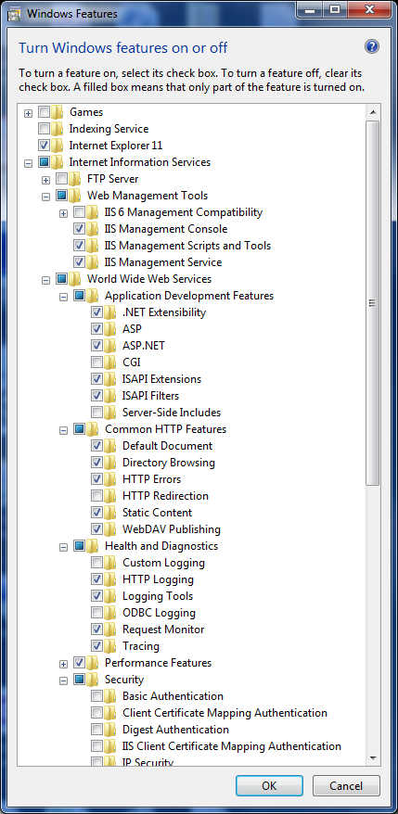Make sure that the following items are installed if not you need to install them.

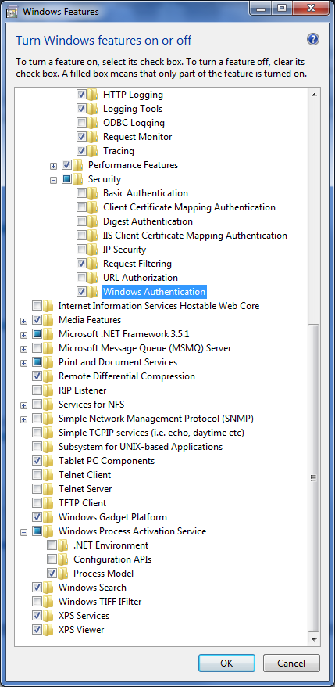

Create a new folder in the C: directory and name it AutomationWorker.

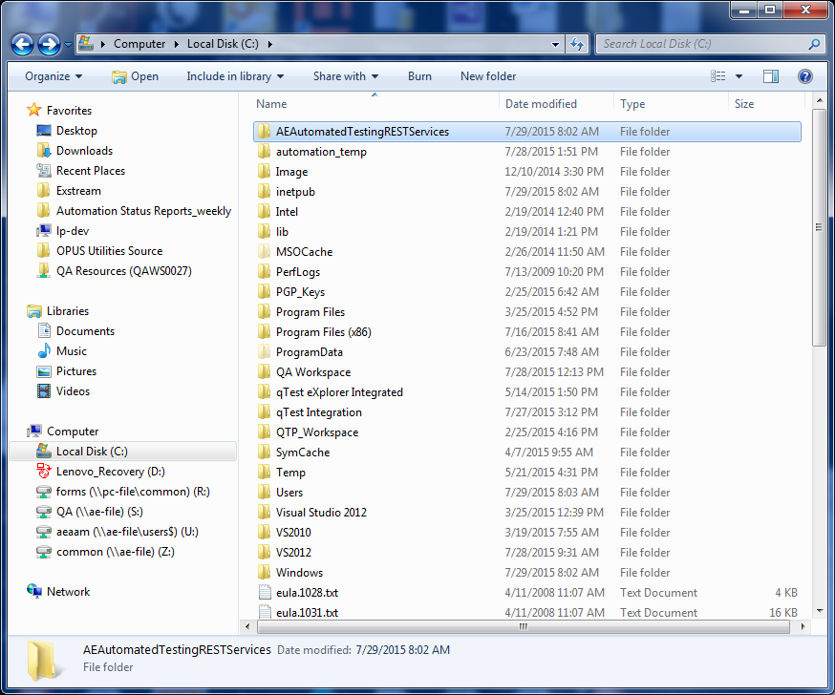

Now select the newly created folder and set the following user and group permissions for folder sharing.

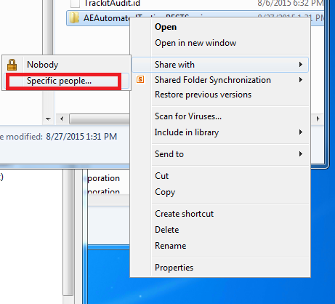

IUSR – Read/Write  
<AD Groups> – Set read for those who will be running the service.

You also need to make sure that in UFT that the setting to allow other HP products to run tests and components. This can be found under Options -> GUI Testing -> Test Runs

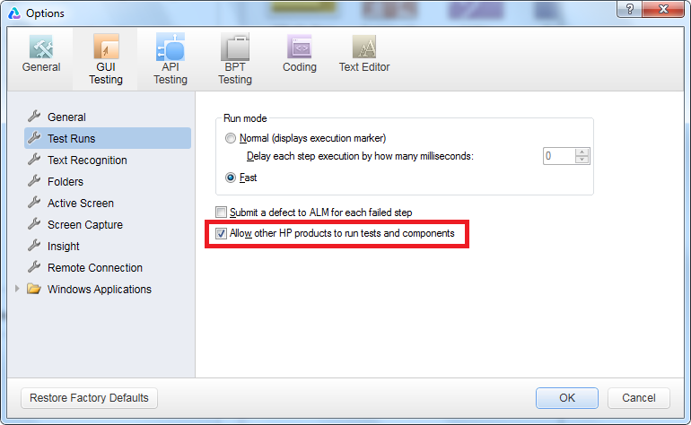

Now run dcomcnfg from the Start -> Run window.

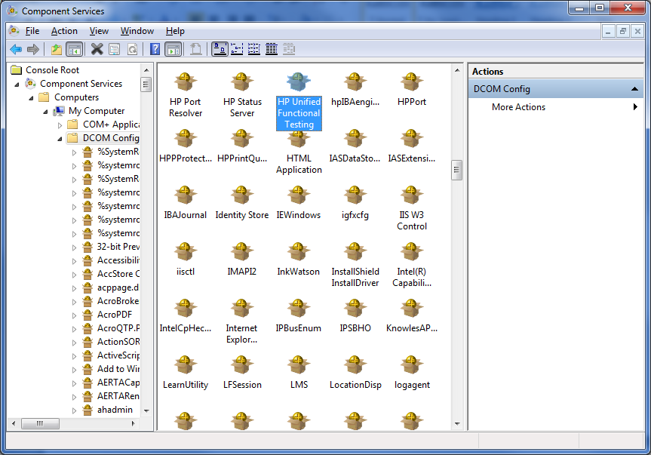

Find HP Unified Functional Testing then right-click and select properties.

When the properties window is visible click on Identity and make sure it is set to The Interactive User.

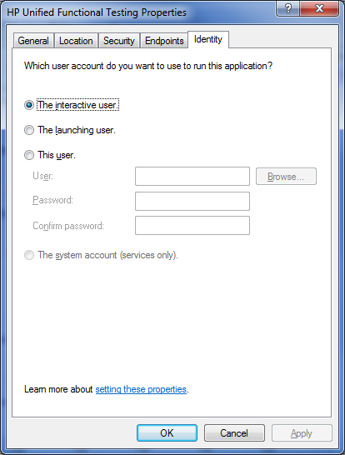

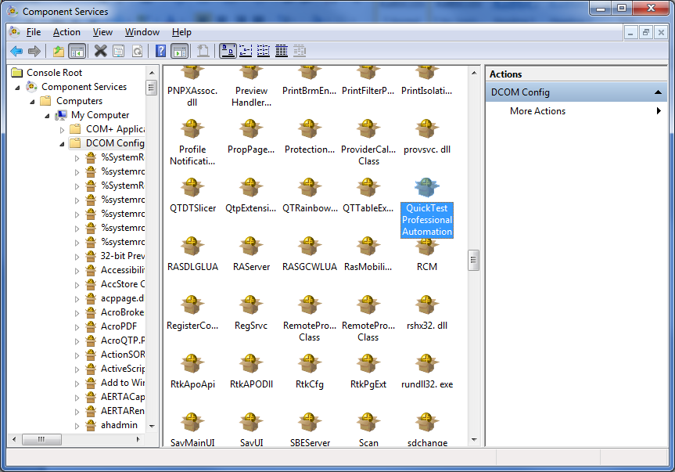

Also check the properties for the QuickTest Professional Automation object and make sure it is set to the Interactive User.

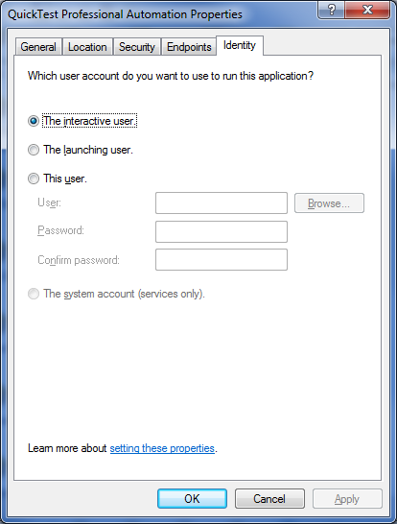

**NOTE: You Need to wait for the windows feature install to complete before building out the new website.**

Go to Control Panel -> Administrative Tools -> Internet Information Services (IIS) Manager

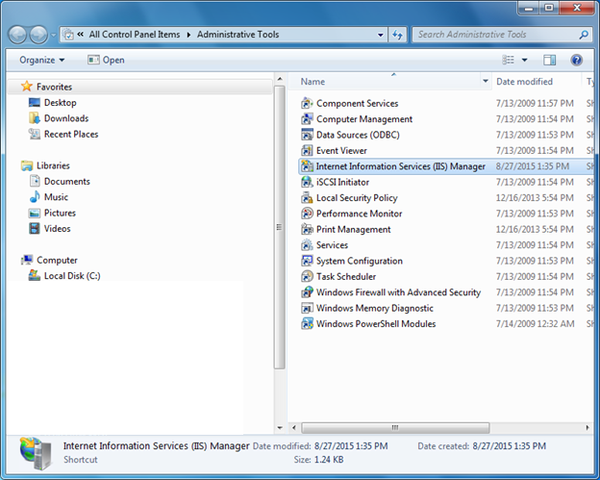

Right-click on the Sites folder and select Add Web Site then set the following values.

Site name: AutomationWorker

Physical path: C:\AutomationWorker

Now click OK.

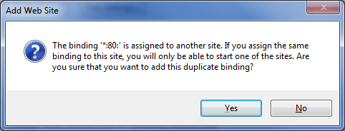

Click Yes to continue.

Make sure you select the Default Web Site and stop it before you start the AE Automated Testing REST Services site.

Right-click on the default web site select Manage Web Site then click Stop.

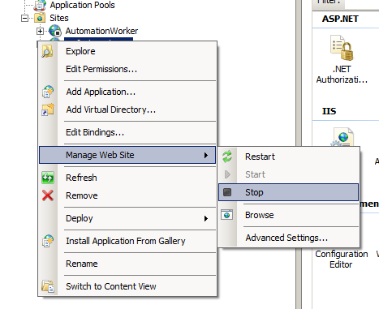

Right-click the AutomationWorker then select Manage Web Site and click on Start

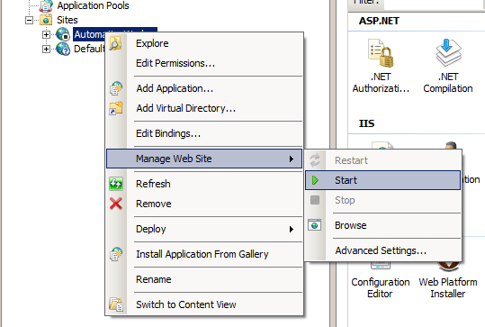

In IIS select Authentication icon in the IIS section and enable Windows Authentication.

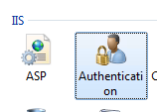

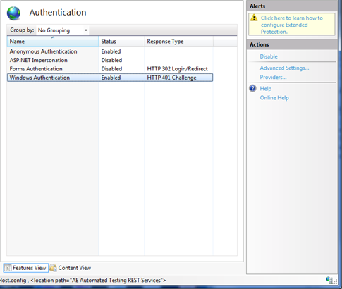

Select the machine name node in the tree and update the .NET version for the entire IIS system.  
In the actions side tray select Change .NET Framework Version.

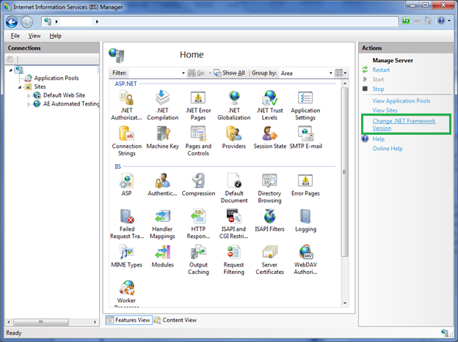

Set it to v4.0.XXXXX and click ok.

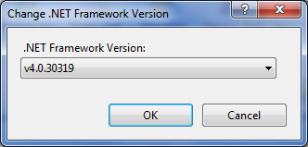

Select the Automation Worker web site and click on the Advanced Settings.

You also need to update the Connection Time-out to 14400 seconds (4 hours) in advanced settings for the site. This is due to some of our scripts executing multiple iterations and taking longer than a few minutes. In the future we plan to modify the scripts so each script item will be a single scenario.

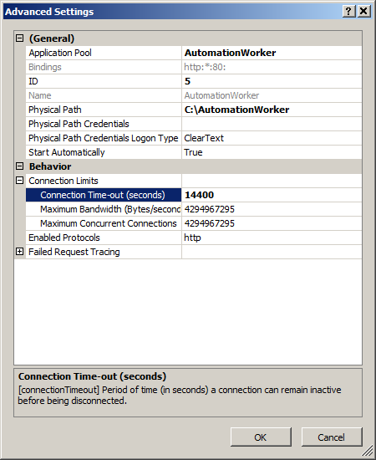

Then in application pools section find the service and double-click it.

Set the .NET Framework version to v4.0.30319

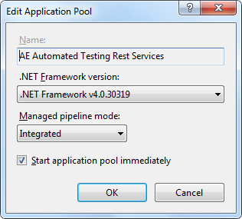

Now click on the Advanced Settings and update the following fields.

.NET Framework Version = v4.0

Identity = LocalSystem

Shutdown Time Limit(seconds) = 14400 (4 Hours) – due to length of a running script.

Request Limit = 1 – This makes it recycle UFT after each use. If you don’t change this from 0 it will cause the service to be unstable.

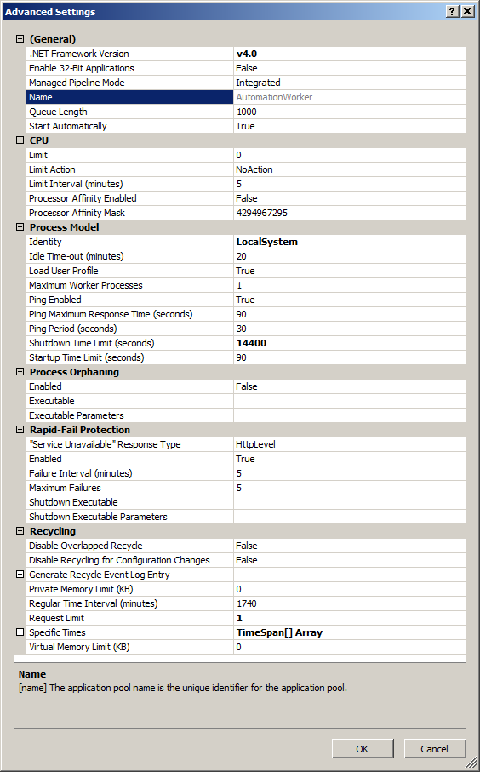

Updating the Web.config for the Automation Foreman.

Find the

<appSettings>

<add key="webpages:Version" value="3.0.0.0" />

<add key="webpages:Enabled" value="false" />

<add key="ClientValidationEnabled" value="true" />

<add key="UnobtrusiveJavaScriptEnabled" value="true" />

<add key="labMachines" value="LAB01;LAB02"/>

<add key="qTestServer" value="qTest_server_URL"/>

<add key="integrationUser" value="qTest@domain.com"/>

<add key="integrationPassword" value="password"/>

<add key="qTestLoginAuth" value="Basic BASE64ENCODEDAUTHORIZATIONSTRING"/>

</appSettings>

**labMachines** - List all of your lab machine names separated by semicolons

**qTestServer** - URL of your qTest server.

**integrationUser** - e-mail address of the qTest user account you are using as an integration account.

**integrationPassword** - password of the qTest user account you are using for the integration

**qTestLoginAuth** - Authorization token used when making the initial login call.

Replace “BASE64ENCODEDAUTHORIZATIONSTRING” with the base64 encoding of the integrationUser e-mail address and the colon(“:”) character. e.g. qTest@domain.com:

Save the Web.config file and continue.

At this point you must deploy the application to the lab machine using Visual Studio .NET File System Deploy.

Once the visual studio solution is opened then right-click on the project name and select the publish option.

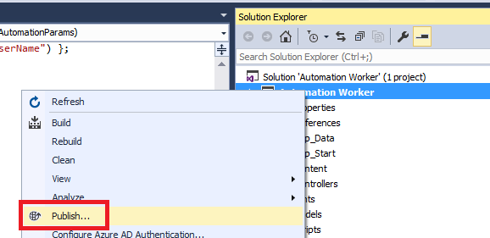

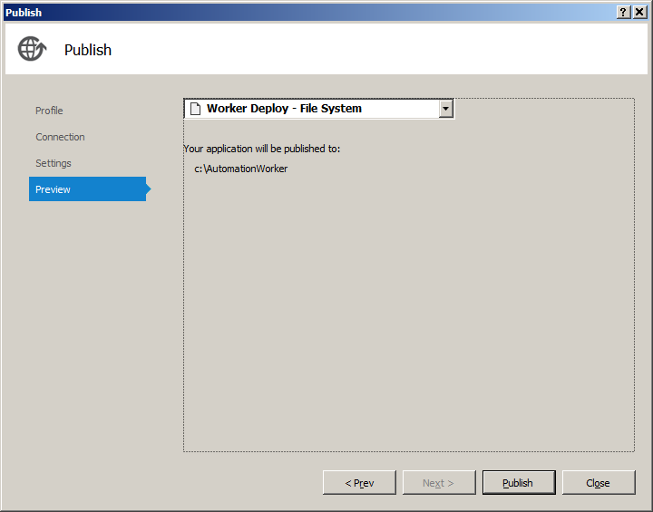

Select the Worker Deploy – File System and then click Publish.  
This can be done to as many machines as you have UFT installed and have licenses for.

The deployment success or failure can be seen in the Output window.

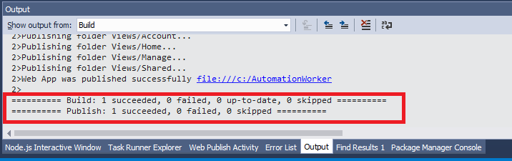

Now you need to verify that the service is up and running. In a browser on your local machine enter the url below and replace<computername> with the computer name you just deployed to.

http://<computername>/api/UFTAutomation

You should see the following response from all of the Automation Worker services.

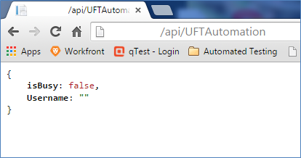

You have now installed the Automation Worker service that will allow you to execute UFT scripts on you lab machine.

If you get a 500.21 error

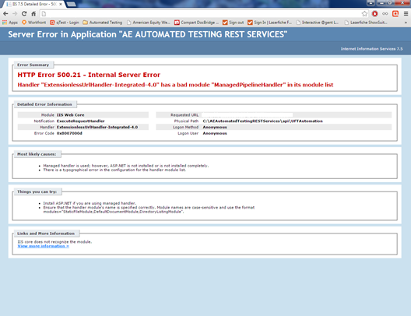

then open a command window browse to   
C:\Windows\Microsoft.NET\Framework64\v4.0.30319\ then enter aspnet_regiis -i and press enter.

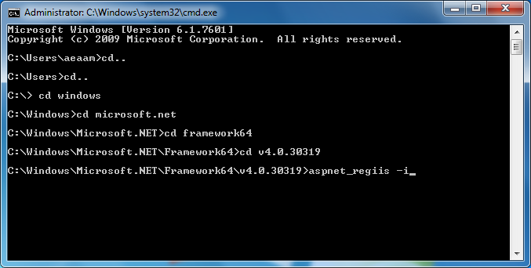

Now you can check the service again and see if you get the expected response shown prior to the information about the 500.21 error.

**NOTE:** When making calls to this service, there must be a user logged into the lab machine in order for UFT to execute properly.

**Automation Foreman Service Setup**

At this point you must deploy the application to the lab machine using Visual Studio .NET File System Deploy.

Once the visual studio solution is opened then right-click on the project name and select the publish option.

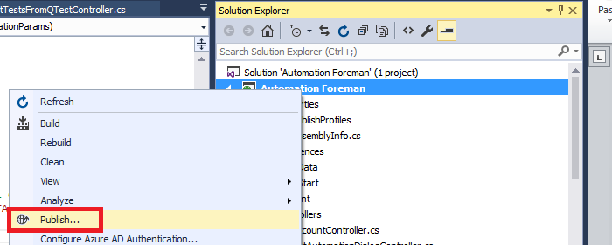

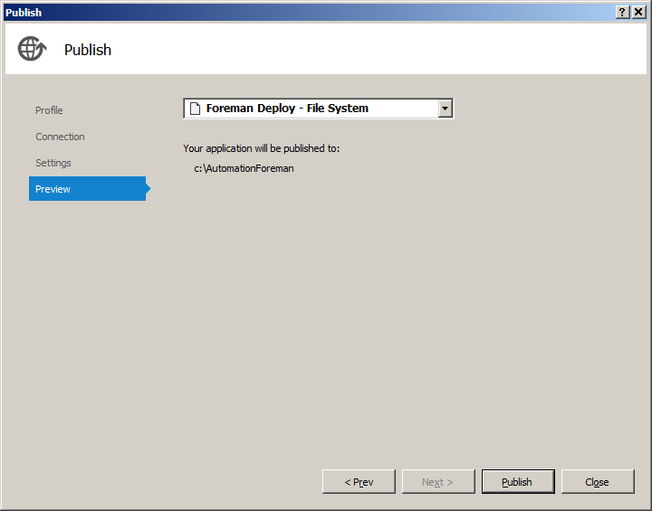

Select Foreman Deploy – File System and then click Publish.  
This can be done to as many machines as you have UFT installed and have licenses for.

The deployment success or failure can be seen in the Output window.

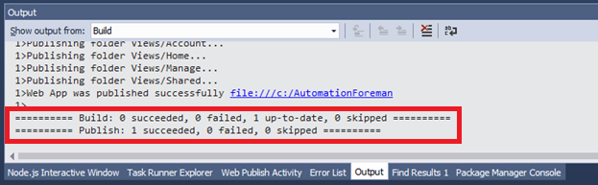

.NET Framework Version = v4.0

Shutdown Time Limit(seconds) = 14400 (4 Hours) – due to length of a running script on the Automation Worker service.

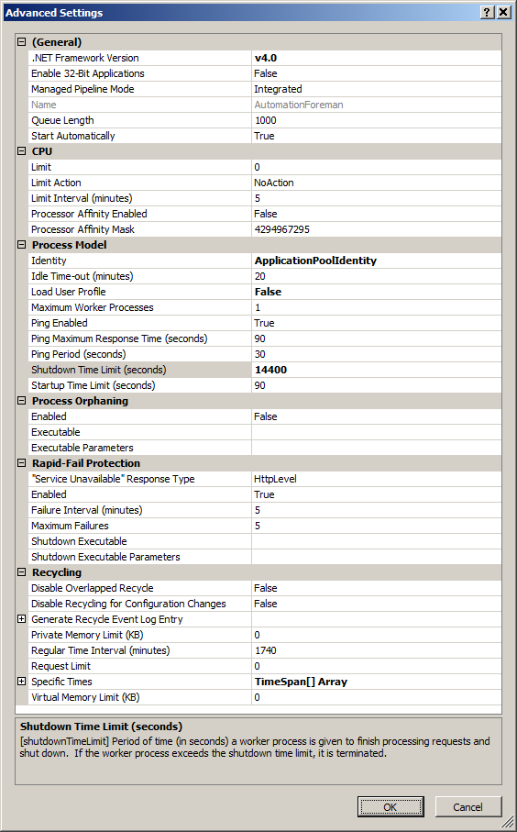

**Execute qTest Test Runs Setup**

In the background.js file find the automation_foreman_getautomationdialog constant and set the url of your Automation Forman site. Typically the machine name, unless you set up a DNS alias.

const automation_foreman_getautomationdialog = “http://<yourcompany.com>/api/GetAutomationDialog/';

**NOTE:** I would recommend that you create a google developer account and publish a private Chrome extension.

Enabling the chrome extension locally.

In Google Chrome click on the Customize and control Google Chrome button.



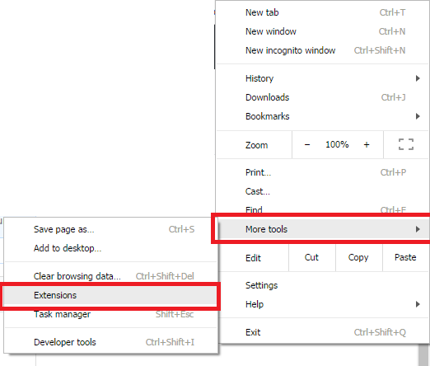

Select Developer mode.

Then click on the Load unpacked extension and point to the folder that contains the background.js and manifest.json and images folder.

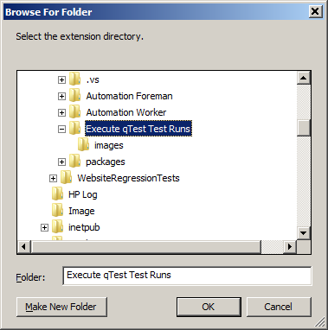

Click Ok.

To use the extension, browse to your qTest Manager site and select a project.

Select the Test Execution tab and then click on either a Test Suite or Test Run and click on the

blue gear chrome extension.

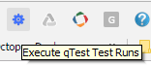

**NOTE:** When making calls to this service, there must be a user logged into the lab machine in order for UFT to execute properly.

You will see a listing of all automated tests in this list and can pick and choose which ones to execute and direct the tests to execute on specific lab machines. Then click Execute Scripts.

